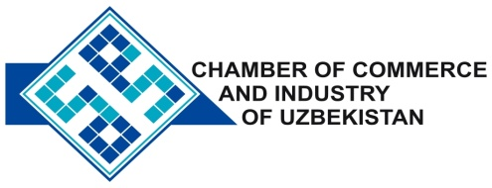

**Commercial offer of Uzbek Products to Foreign Buyer**

Dear Sirs, KP - 017

We offer quotation of Uzbek Company PE "Aliyev AD"

**Information about the company:**

The company PE "Aliyev AD" It was founded in 2000. The main activity of the company is production of magnesium nitrate, calcium, potassium.

**List of products:**

Magnesium nitrate

Calcium nitrate

potassium nitrate

**Benefits:**

Production PE «Aliyev AD» - The only source of water-soluble calcium and is essential for plant growth, both in the open and in greenhouses.

**Terms of delivery:** FCA Tashkent

If you are interested, we are happy to provide additional information in accordance with your request.

E-mail: [export@chamber.uz](mailto:export@chamber.uz)

Website: [www.chamber.uz](http://www.chamber.uz)

Export Promotion Department.

Chamber of Commerce of the Republic of Uzbekistan.